# Making ASP.NET Core MVC Apps into Single Page Apps using AppRun

<https://medium.com/@yiyisun/making-asp-net-core-mvc-apps-into-single-page-apps-using-apprun-e1ae4dbc60da>

*A single-page application (SPA) is a web application or web site that interacts with the user by dynamically rewriting the current page rather than loading entire new pages from a server. This approach avoids interruption of the user experience between successive pages, making the application behave more like a desktop application.*

*— From*[*Wikipedia*](https://en.wikipedia.org/wiki/Single-page_application)

If you have invested and build applications using the server-side technology, such as ASP.NET MVC and ASP.NET Core MVC, you probably know that it is hard to make the server-side rendered applications into the single-page applications. You will need to change the server-side routes to be the Web API that returns data in JSON format. You will also need to develop the client-side templates and state management to handle the JSON data. It is like re-develop the application. After you’ve done the work, you have a single-page application. However, you will find out that now you are missing the server-side rendering capability to improve the first loading time and to support SEO.

I give you a good news. Use [AppRun](https://github.com/yysun/apprun).

AppRun is a 3K library for developing applications using the elm inspired architecture, events and components.

You can make your server-side rendered apps into the single-page apps instantly, just like sprinkling a little magic of AppRun.



Photo by Sharon McCutcheon from Pexels

How does it work?

When the first time users visitor the pages of the app, the app returns the HTML. Business as usual.

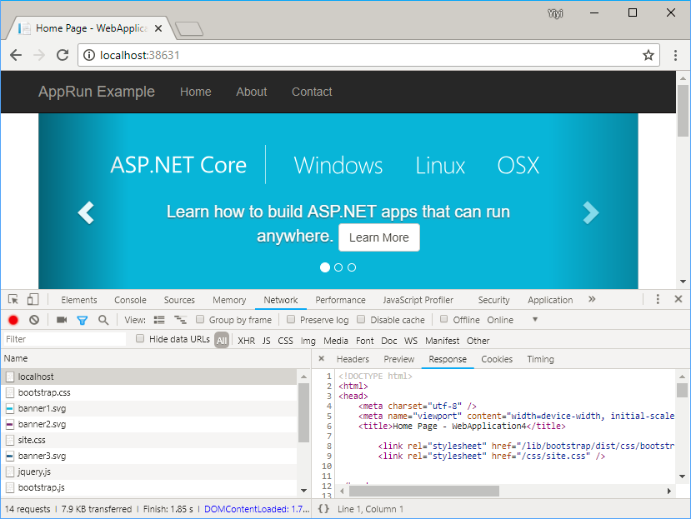

App returns HTML

Once the app is loaded, the client-side AppRun app switches the app into the single-page app mode. When users click the page links, the app returns the virtual DOM from the server. The client-side AppRun renders the virtual DOM to the real DOM.

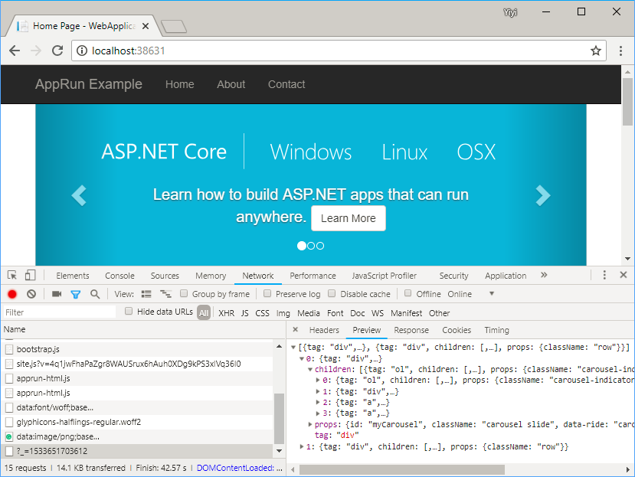

App returns Virtual DOM

How to Make it?

First, we include the [Virtual DOM filter attribute](https://github.com/yysun/apprun-ssr-aspnet-core/blob/master/WebApplication4/VirtualDomAttribute.cs) into the project. Then, we apply the filter attribute to the server-side routes.

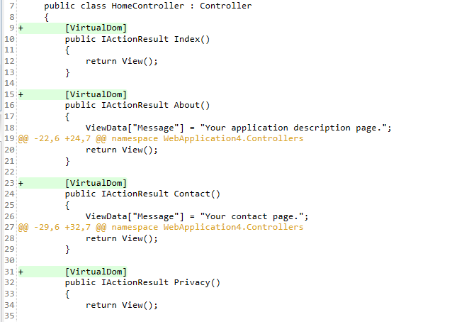

Apply the Virtual DOM Filter

Then, we add a client-side AppRun app to the _Layout.cshtml.

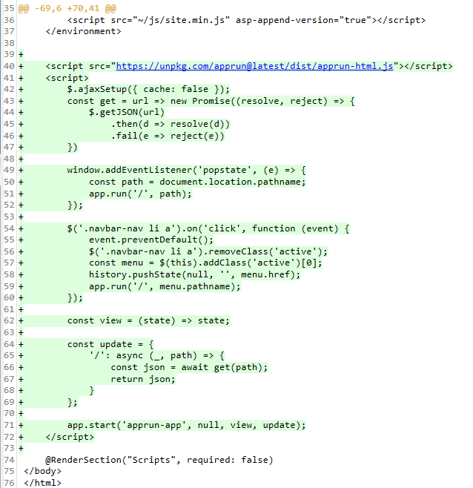

The Client-Side AppRun App

Finally, we wrap the page container with a div element, <div id=”apprun-app”/>.



Element for the AppRun App

That’s all the magic you need! How easy it is? Download and try it yourself.

<https://github.com/yysun/apprun-ssr-aspnet-core>

Also, if you have non-Core version of ASP.NET MVC 5.x applications, you can do the exactly the same.

[https://github.com/yysun/apprun-ssr-aspnet](https://github.com/yysun/apprun-ssr-aspnet-core)

I plan to create a NuGet package to make it even easier to use, but cannot I wait to share the idea to those might have interests earlier.

Conclusion

AppRun is a powerful client-side framework. It can instantly make server-rendered applications into the single-page applications. Best of all, it is non-destructive to your existing application logic.

The same idea applies to the applications using other server-side technologies. I have successfully applied the idea to Wordpress applications. I am working on express.js (Node.js) and Laravel (PHP) examples. I will write posts about them in the future. Stay tuned.